AI-ASSISTED CODING
ASSIGNMENT-14.1
Web Design Application – AI-Assisted HTML/CSS/JS
Generation

NAME: ADEPU GOUTHAM SRI BHARGAV
HALL-TICKET: 2403A510C4
BATCH NO: 05

TASK-1:
You are building a personal portfolio website to showcase your work.
Requirements:
• Create sections for About Me, Projects, and Contact.
• Use AI to:
o Suggest color palettes and typography.
o Create a responsive layout with Grid/Flexbox.
o Add smooth scrolling navigation
Prompt:
Create a personal portfolio website using HTML, CSS, and JavaScript. Include sections for About Me, Projects, and Contact. Use a responsive layout with Flexbox or Grid, add smooth scrolling navigation, and suggest a matching color palette and typography. include 3 sample projects and a space to upload my own profile image.
CODE GENERATED:
<!doctype html>
<html lang="en">
<head>
<meta charset="utf-8" />
<meta name="viewport" content="width=device-width,initial-scale=1" />
<title>My Portfolio</title>

<!-- Google font (optional; remove if offline) -->
<link href="https://fonts.googleapis.com/css2?family=Poppins:wght@300;400;600;700&display=swap" rel="stylesheet">

<style>
:root{
--primary:#1a1a2e;
--secondary:#0f3460;
--accent:#e94560;
--bg:#f5f6fa;
--text:#222;
--header-h:72px; /* used for offset when header is fixed */
}

*{box-sizing:border-box}
html,body{height:100%; margin:0; font-family:"Poppins",system-ui,-apple-system,Segoe UI,Roboto,"Helvetica Neue",Arial; color:var(--text); background:var(--bg); scroll-behavior: smooth;}

/* Fixed header */
header{
position:fixed; inset:0 0 auto 0; height:var(--header-h);
display:flex; align-items:center; justify-content:center;
background:var(--primary); color:#fff; z-index:1200;
box-shadow:0 2px 8px rgba(0,0,0,0.12);
padding:0 20px;
}
nav{display:flex; gap:20px; align-items:center;}
nav a{color:#fff; text-decoration:none; font-weight:600; padding:8px 10px; border-radius:6px; transition:background .18s, color .18s}
nav a:hover{background:rgba(255,255,255,0.05); color:var(--accent);}

/* ensure content isn't hidden behind fixed header */
main{padding-top:calc(var(--header-h) + 28px); max-width:1100px; margin:0 auto;}

/* sections */
section{padding:48px 20px; margin-bottom:10px; background:transparent}
h2{margin:0 0 18px; text-align:center; color:var(--secondary); font-size:1.9rem}

/* ABOUT */
#about{display:flex; flex-direction:column; align-items:center; text-align:center;}
#about img{width:140px; height:140px; object-fit:cover; border-radius:50%; border:4px solid var(--accent); margin-bottom:18px}
#about p{max-width:760px; line-height:1.6}

/* PROJECTS */
#projects .grid{display:grid; gap:22px; grid-template-columns:repeat(auto-fit,minmax(300px,1fr));}
.card{background:#fff; border-radius:12px; padding:18px; box-shadow:0 6px 18px rgba(15,20,40,0.06); transition:transform .25s, box-shadow .25s}
.card:hover{transform:translateY(-6px); box-shadow:0 14px 30px rgba(15,20,40,0.09)}
.card h3{margin:6px 0 8px; color:var(--accent)}
.card p{margin:0 0 12px; line-height:1.5}
.card .meta{font-size:.9rem; color:#555}

.project-actions{margin-top:10px; display:flex; gap:10px; align-items:center}
.btn{display:inline-block; padding:8px 12px; border-radius:8px; text-decoration:none; font-weight:600; border:1px solid transparent}
.btn-outline{background:transparent; color:var(--secondary); border-color:rgba(15,52,96,0.08)}
.btn-solid{background:var(--accent); color:#fff}

/* CONTACT */
#contact form{max-width:520px; margin:0 auto; display:flex; flex-direction:column; gap:12px}
input,textarea{padding:12px; border-radius:8px; border:1px solid #d7d7d7; font-size:1rem; width:100%}
button{padding:12px 14px; border-radius:8px; border:none; background:var(--accent); color:#fff; font-weight:600; cursor:pointer}
#form-msg{display:none; margin-top:8px; text-align:center; color:var(--secondary)}

/* small screens */
@media (max-width:640px){
nav{gap:12px}
h2{font-size:1.6rem}
}

/* helpful: ensure anchors don't land under header on browsers without JS */
section{scroll-margin-top:calc(var(--header-h) + 8px)}
</style>
</head>
<body>

<header>
<nav>
<a href="#about">About</a>
<a href="#projects">Projects</a>
<a href="#contact">Contact</a>
</nav>
</header>

<main>
<!-- ABOUT -->
<section id="about" aria-labelledby="about-heading">
<img src="myphoto.jpg" alt="My Photo">
<h2 id="about-heading">About Me</h2>
<p>Hello — I'm a web developer focused on clean, responsive interfaces and useful front-end features. I build projects with HTML, CSS, and JavaScript, and I love tiny details that make user experiences smoother.</p>
</section>

<!-- PROJECTS (only 3) -->
<section id="projects" aria-labelledby="projects-heading">
<h2 id="projects-heading">Projects</h2>
<div class="grid">
<article class="card" aria-labelledby="p1-title">
<h3 id="p1-title">Personal Portfolio</h3>
<p class="meta">HTML • CSS Grid • Responsive Design</p>
<p>Self-hosted portfolio that showcases my work, contact form (demo), and modern layout built with Grid + Flexbox.</p>
<div class="project-actions">
<a class="btn btn-outline" href="#" aria-label="Open live demo for Portfolio">Live demo</a>
<a class="btn btn-solid" href="#" aria-label="Open GitHub repo for Portfolio">Source</a>
</div>
</article>

<article class="card" aria-labelledby="p2-title">
<h3 id="p2-title">Weather App</h3>
<p class="meta">JavaScript • API • Progressive</p>
<p>Fetches real-time weather from OpenWeather (demo) with location search, icons, and mobile-first UI.</p>
<div class="project-actions">
<a class="btn btn-outline" href="#">Live demo</a>
<a class="btn btn-solid" href="#">Source</a>
</div>
</article>

<article class="card" aria-labelledby="p3-title">
<h3 id="p3-title">Task Tracker</h3>
<p class="meta">Vanilla JS • localStorage</p>
<p>Small productivity app: add/edit/delete tasks, persist to localStorage, and filter completed items.</p>
<div class="project-actions">
<a class="btn btn-outline" href="#">Live demo</a>
<a class="btn btn-solid" href="#">Source</a>
</div>
</article>
</div>
</section>

<!-- CONTACT -->
<section id="contact" aria-labelledby="contact-heading">
<h2 id="contact-heading">Contact</h2>
<form id="contact-form" novalidate>
<input name="name" type="text" placeholder="Your name" required>
<input name="email" type="email" placeholder="Your email" required>
<textarea name="message" rows="5" placeholder="Your message"></textarea>
<button type="submit">Send message</button>
<div id="form-msg" role="status" aria-live="polite"></div>
</form>
</section>
</main>

<footer style="text-align:center;padding:20px 10px;color:#fff;background:var(--primary)">
© 2025 My Portfolio — Built with ❤️ and AI
</footer>

<script>
// DOM ready
document.addEventListener('DOMContentLoaded', () => {
const header = document.querySelector('header');
const headerHeight = header.getBoundingClientRect().height;

// Smooth scrolling for internal anchors — adjusts for fixed header
document.querySelectorAll('a[href^="#"]').forEach(link => {
link.addEventListener('click', (e) => {
const href = link.getAttribute('href');
if (!href || href === '#') return;
const target = document.querySelector(href);
if (!target) return;
e.preventDefault();

const targetY = target.getBoundingClientRect().top + window.pageYOffset - headerHeight - 12;
window.scrollTo({ top: Math.max(targetY, 0), behavior: 'smooth' });

// update URL hash without jumping
history.pushState(null, '', href);
});
});

// Simple contact form demo handler (prevents real submission)
const form = document.getElementById('contact-form');
const msg = document.getElementById('form-msg');
form.addEventListener('submit', (e) => {
e.preventDefault();
const data = new FormData(form);
const name = data.get('name') || 'there';
console.log('Contact form submitted (demo):', Object.fromEntries(data));
msg.textContent = `Thanks ${name}! Message received (demo).`;
msg.style.display = 'block';

// reset input after brief delay to show message
form.reset();
setTimeout(() => msg.style.display = 'none', 4000);
});

// Optional: highlight current nav as you scroll (basic)
const sections = document.querySelectorAll('main section[id]');
const navLinks = Array.from(document.querySelectorAll('nav a'));
const obs = new IntersectionObserver(entries => {
entries.forEach(entry => {
const id = entry.target.id;
const link = document.querySelector(`nav a[href="#${id}"]`);
if (!link) return;
if (entry.isIntersecting) {
navLinks.forEach(a => a.style.opacity = '0.6');
link.style.opacity = '1';
}
});
}, { root: null, threshold: 0.45 });

sections.forEach(s => obs.observe(s));
});
</script>
</body>
</html>

OUTPUT:
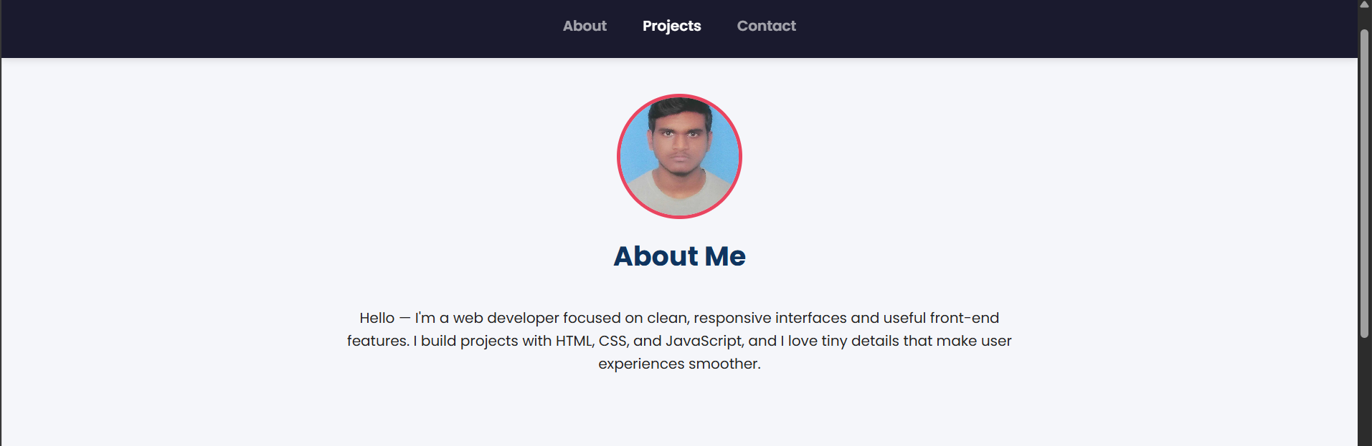
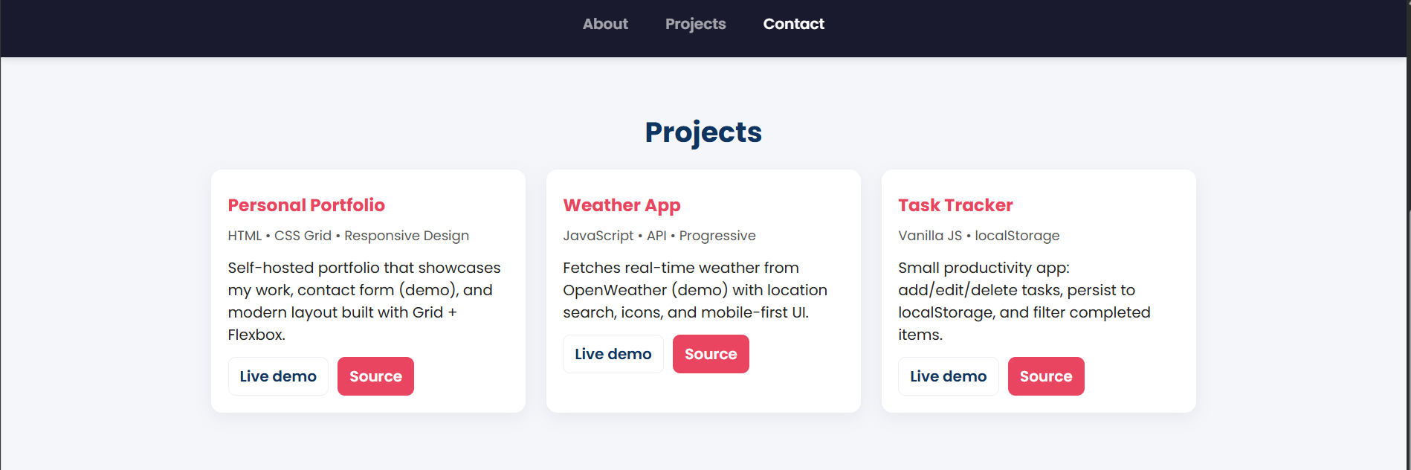
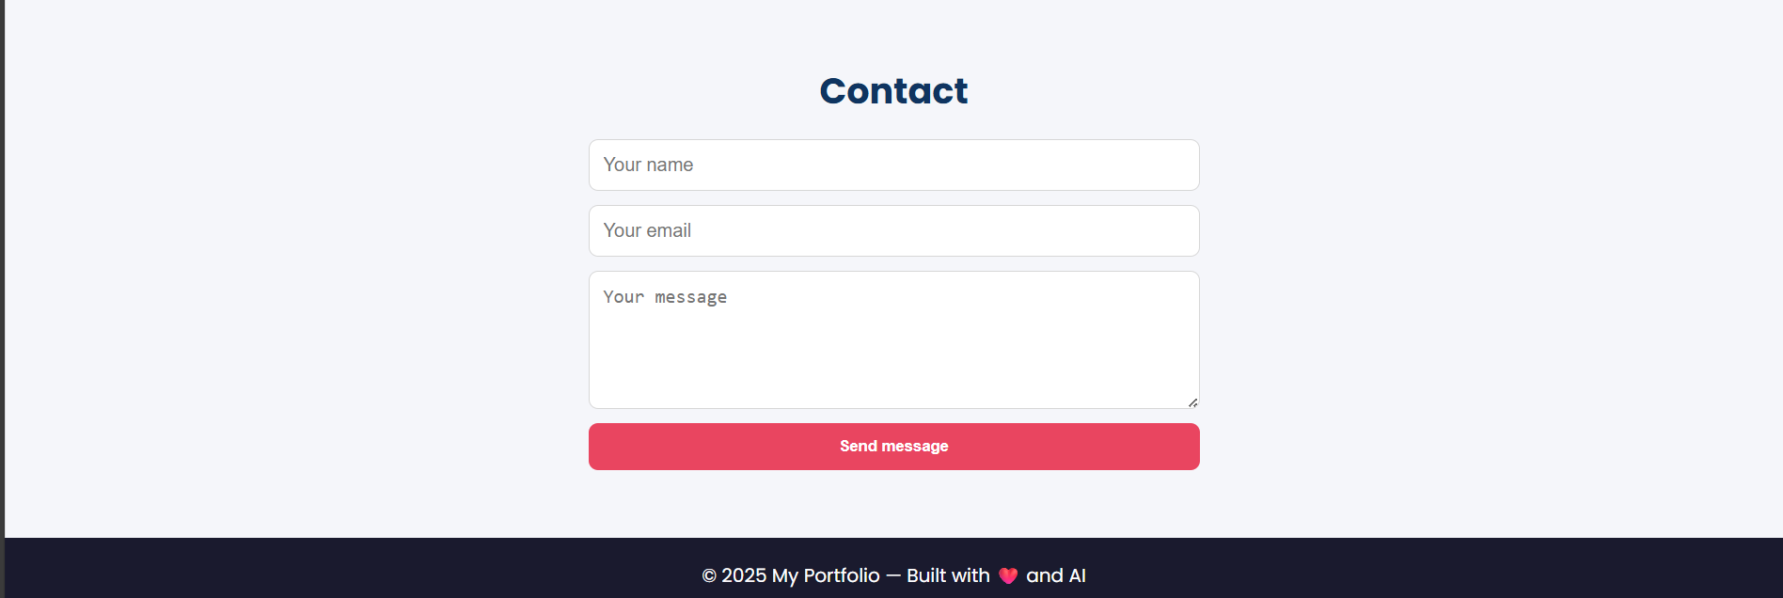
OBSERVATION :
The personal portfolio website is clean, responsive, and easy to navigate. It includes well-organized sections for About Me, Projects, and Contact. Smooth scrolling and a simple color scheme make it visually appealing and user-friendly on both desktop and mobile devices

TASK -2:
Design a product display page for an online store.
Requirements:
• Display product image, title, price, and "Add to Cart" button.
• Use AI to:
o Style with BEM methodology.
o Make layout responsive.
o Add hover effects and "Add to Cart" alert
PROMPT:
Create a responsive product display page for an online store using HTML, CSS, and JavaScript.
Display multiple products in a grid layout with image, title, price, and “Add to Cart” button.
Use BEM methodology for CSS, add hover effects, and show an alert when a product is added to the cart.
CODE GENERATED:
<!DOCTYPE html>
<html lang="en">
<head>
<meta charset="UTF-8">
<meta name="viewport" content="width=device-width, initial-scale=1.0">
<title>Online Store - Products</title>
<link href="https://fonts.googleapis.com/css2?family=Poppins:wght@300;400;600;700&display=swap" rel="stylesheet">
<style>
/* === Base Styles === */
* { box-sizing: border-box; margin: 0; padding: 0; }
body {
font-family: 'Poppins', sans-serif;
background-color: #f4f5f7;
color: #333;
padding: 40px 20px;
}

h1 { text-align: center; margin-bottom: 30px; color: #1a1a2e; }

/* === Product Grid === */
.products {
display: grid;
grid-template-columns: repeat(auto-fit, minmax(220px, 1fr));
gap: 25px;
max-width: 1200px;
margin: auto;
}

/* === Product Card BEM === */
.product-card {
background: #fff;
border-radius: 12px;
overflow: hidden;
box-shadow: 0 4px 12px rgba(0,0,0,0.1);
transition: transform 0.3s, box-shadow 0.3s;
display: flex;
flex-direction: column;
align-items: center;
text-align: center;
padding-bottom: 15px;
}

.product-card:hover {
transform: translateY(-8px);
box-shadow: 0 10px 20px rgba(0,0,0,0.15);
}

.product-card__image {
width: 100%;
height: 200px;
object-fit: cover;
}

.product-card__title {
font-size: 1.1rem;
font-weight: 600;
margin: 12px 0 6px;
color: #1a1a2e;
}

.product-card__price {
font-size: 1rem;
color: #28a745;
margin-bottom: 12px;
font-weight: 500;
}

.product-card__button {
background-color: #007bff;
color: white;
border: none;
padding: 10px 18px;
border-radius: 8px;
cursor: pointer;
transition: background-color 0.3s;
font-weight: 500;
}

.product-card__button:hover {
background-color: #0056b3;
}

/* === Responsive Text === */
@media (max-width: 480px) {
.product-card__title { font-size: 1rem; }
.product-card__price { font-size: 0.95rem; }
}
</style>
</head>
<body>

<h1>Our Products</h1>

<div class="products">

<div class="product-card">
<img src="https://via.placeholder.com/300x200?text=Headphones" alt="Wireless Headphones" class="product-card__image">
<h2 class="product-card__title">Wireless Headphones</h2>
<p class="product-card__price">$59.99</p>
<button class="product-card__button" onclick="addToCart('Wireless Headphones')">Add to Cart</button>
</div>

<div class="product-card">
<img src="https://via.placeholder.com/300x200?text=Smartwatch" alt="Smartwatch" class="product-card__image">
<h2 class="product-card__title">Smartwatch</h2>
<p class="product-card__price">$129.99</p>
<button class="product-card__button" onclick="addToCart('Smartwatch')">Add to Cart</button>
</div>

<div class="product-card">
<img src="https://via.placeholder.com/300x200?text=Camera" alt="Digital Camera" class="product-card__image">
<h2 class="product-card__title">Digital Camera</h2>
<p class="product-card__price">$499.99</p>
<button class="product-card__button" onclick="addToCart('Digital Camera')">Add to Cart</button>
</div>

<div class="product-card">
<img src="https://via.placeholder.com/300x200?text=Laptop" alt="Laptop" class="product-card__image">
<h2 class="product-card__title">Laptop</h2>
<p class="product-card__price">$899.99</p>
<button class="product-card__button" onclick="addToCart('Laptop')">Add to Cart</button>
</div>

<div class="product-card">
<img src="https://via.placeholder.com/300x200?text=Shoes" alt="Sports Shoes" class="product-card__image">
<h2 class="product-card__title">Sports Shoes</h2>
<p class="product-card__price">$79.99</p>
<button class="product-card__button" onclick="addToCart('Sports Shoes')">Add to Cart</button>
</div>

<div class="product-card">
<img src="https://via.placeholder.com/300x200?text=Backpack" alt="Travel Backpack" class="product-card__image">
<h2 class="product-card__title">Travel Backpack</h2>
<p class="product-card__price">$49.99</p>
<button class="product-card__button" onclick="addToCart('Travel Backpack')">Add to Cart</button>
</div>

</div>

<script>
function addToCart(productName) {
alert(`✅ ${productName} added to cart successfully!`);
}
</script>

</body>
</html>

OUTPUT:
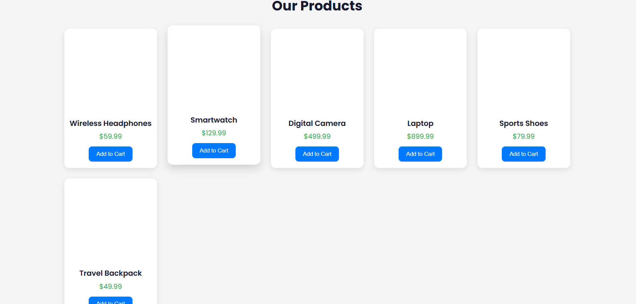
OBSERVATION:
The product display page is clean, modern, and responsive. Products are shown in a grid with images, titles, prices, and “Add to Cart” buttons. Hover effects and alert messages enhance interactivity, and the layout works well on both desktop and mobile devices.

TASK – 3:
Build an event registration form for a conference.
Requirements:
• Collect name, email, phone number, and session selection.
• Use AI to:
o Add form validation with JavaScript.
o Make the form accessible with labels and ARIA.
o Style with a professional look.
PROMPT:
Build an event registration form for a conference using HTML, CSS, and JavaScript.
Collect name, email, phone number, and session selection.
Add form validation, accessible labels and ARIA attributes, and style it with a professional design.

CODE GENERATED:
<!DOCTYPE html>
<html lang="en">
<head>
<meta charset="UTF-8">
<meta name="viewport" content="width=device-width, initial-scale=1.0">
<title>Conference Registration Form</title>
<link href="https://fonts.googleapis.com/css2?family=Poppins:wght@300;400;600;700&display=swap" rel="stylesheet">
<style>
/* === Base Styles === */
body {
font-family: 'Poppins', sans-serif;
background-color: #f4f5f7;
display: flex;
justify-content: center;
align-items: center;
min-height: 100vh;
margin: 0;
padding: 20px;
}

.registration-form {
background: #fff;
padding: 30px 25px;
border-radius: 12px;
box-shadow: 0 8px 20px rgba(0,0,0,0.12);
width: 100%;
max-width: 450px;
}

.registration-form h2 {
text-align: center;
margin-bottom: 25px;
color: #1a1a2e;
}

.form-group {
margin-bottom: 18px;
display: flex;
flex-direction: column;
}

label {
font-weight: 500;
margin-bottom: 6px;
}

input, select {
padding: 10px 12px;
border-radius: 6px;
border: 1px solid #ccc;
font-size: 1rem;
}

input:focus, select:focus {
outline: none;
border-color: #007bff;
box-shadow: 0 0 5px rgba(0,123,255,0.3);
}

button {
width: 100%;
padding: 12px;
border: none;
border-radius: 8px;
background-color: #007bff;
color: #fff;
font-weight: 600;
font-size: 1rem;
cursor: pointer;
transition: background 0.3s;
}

button:hover {
background-color: #0056b3;
}

.error-message {
color: #e94560;
font-size: 0.9rem;
margin-top: 4px;
display: none;
}

@media (max-width: 480px) {
.registration-form { padding: 20px; }
}
</style>
</head>
<body>

<form class="registration-form" id="registrationForm" aria-labelledby="form-title" novalidate>
<h2 id="form-title">Conference Registration</h2>

<div class="form-group">
<label for="name">Full Name <span aria-hidden="true">*</span></label>
<input type="text" id="name" name="name" aria-required="true">
<span class="error-message" id="nameError">Please enter your name.</span>
</div>

<div class="form-group">
<label for="email">Email <span aria-hidden="true">*</span></label>
<input type="email" id="email" name="email" aria-required="true">
<span class="error-message" id="emailError">Please enter a valid email.</span>
</div>

<div class="form-group">
<label for="phone">Phone Number <span aria-hidden="true">*</span></label>
<input type="tel" id="phone" name="phone" aria-required="true" placeholder="e.g., +1234567890">
<span class="error-message" id="phoneError">Please enter a valid phone number.</span>
</div>

<div class="form-group">
<label for="session">Select Session <span aria-hidden="true">*</span></label>
<select id="session" name="session" aria-required="true">
<option value="">-- Please choose a session --</option>
<option value="morning">Morning Session (9 AM - 12 PM)</option>
<option value="afternoon">Afternoon Session (1 PM - 4 PM)</option>
<option value="evening">Evening Session (5 PM - 8 PM)</option>
</select>
<span class="error-message" id="sessionError">Please select a session.</span>
</div>

<button type="submit">Register</button>
</form>

<script>
const form = document.getElementById('registrationForm');

form.addEventListener('submit', function(e) {
e.preventDefault();

// Clear previous errors
document.querySelectorAll('.error-message').forEach(el => el.style.display = 'none');

let valid = true;

// Name validation
const name = document.getElementById('name');
if(name.value.trim() === "") {
document.getElementById('nameError').style.display = 'block';
valid = false;
}

// Email validation
const email = document.getElementById('email');
const emailPattern = /^[^ ]+@[^ ]+\.[a-z]{2,3}$/;
if(!emailPattern.test(email.value.trim())) {
document.getElementById('emailError').style.display = 'block';
valid = false;
}

// Phone validation
const phone = document.getElementById('phone');
const phonePattern = /^\+?\d{7,15}$/;
if(!phonePattern.test(phone.value.trim())) {
document.getElementById('phoneError').style.display = 'block';
valid = false;
}

// Session validation
const session = document.getElementById('session');
if(session.value === "") {
document.getElementById('sessionError').style.display = 'block';
valid = false;
}

if(valid) {
alert(`✅ Registration successful!\nName: ${name.value}\nSession: ${session.value}`);
form.reset();
}
});
</script>

</body>
</html>

OUTPUT:
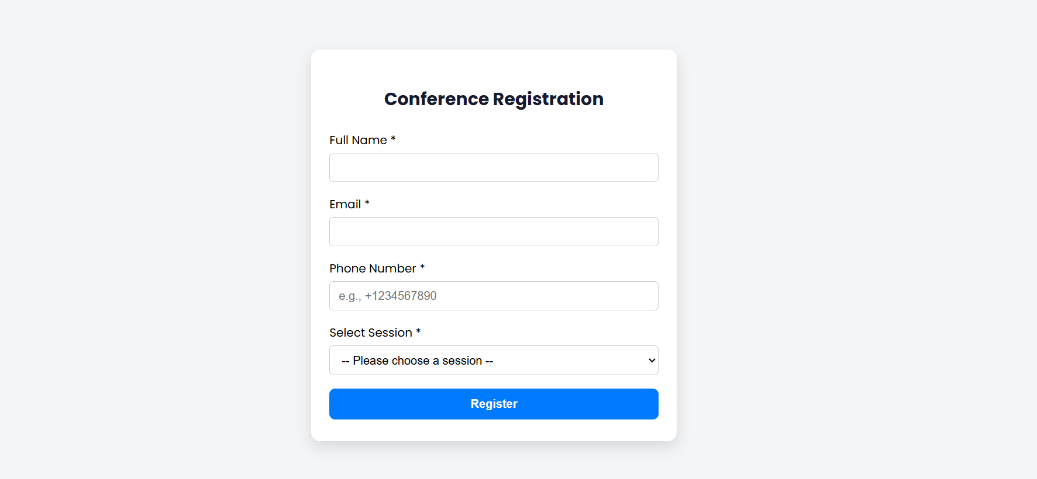

OBSERVATION:
The event registration form is clean, professional, and easy to use. It collects name, email, phone number, and session selection, and provides real-time validation to ensure correct input. Labels and ARIA attributes make it accessible, and the responsive design ensures it works well on both desktop and mobile devices.
TASK – 4:
ask: Fetch JSON from an API and render items to the DOM
with loading and error UI.
• Instructions:
o Ask AI to write fetch() logic, create DOM nodes safely,
and add skeleton/loading text.

PROMPT:
Write a JavaScript program that fetches JSON data from an API, safely creates DOM nodes to display items, and shows a loading indicator while fetching. Include error handling to display a message if the request fails.
CODE GENERATED:
<!DOCTYPE html>
<html lang="en">
<head>
<meta charset="UTF-8">
<meta name="viewport" content="width=device-width, initial-scale=1.0">
<title>Fetch API Items</title>
<style>
body {
font-family: 'Poppins', sans-serif;
padding: 20px;
background: #f4f5f7;
color: #333;
}

h1 {
text-align: center;
margin-bottom: 20px;
color: #1a1a2e;
}

#items {
display: grid;
grid-template-columns: repeat(auto-fit, minmax(250px, 1fr));
gap: 20px;
max-width: 1000px;
margin: auto;
}

.item-card {
background: #fff;
padding: 15px;
border-radius: 10px;
box-shadow: 0 4px 12px rgba(0,0,0,0.08);
transition: transform 0.3s;
}

.item-card:hover {
transform: translateY(-5px);
}

.loading, .error {
text-align: center;
font-size: 1.1rem;
color: #555;
margin-top: 40px;
}

.error { color: #e94560; }
</style>
</head>
<body>

<h1>API Items</h1>
<div id="loading" class="loading">Loading items...</div>
<div id="items"></div>
<div id="error" class="error" style="display:none;"></div>

<script>
const apiURL = 'https://jsonplaceholder.typicode.com/posts?_limit=10'; // Sample API
const itemsContainer = document.getElementById('items');
const loadingEl = document.getElementById('loading');
const errorEl = document.getElementById('error');

// Fetch items from API
fetch(apiURL)
.then(response => {
if(!response.ok) throw new Error('Network response was not ok');
return response.json();
})
.then(data => {
loadingEl.style.display = 'none'; // hide loading
renderItems(data);
})
.catch(err => {
loadingEl.style.display = 'none';
errorEl.textContent = `Error fetching data: ${err.message}`;
errorEl.style.display = 'block';
});

// Render items safely
function renderItems(items) {
items.forEach(item => {
const card = document.createElement('div');
card.className = 'item-card';

// Safely set text
const title = document.createElement('h3');
title.textContent = item.title;

const body = document.createElement('p');
body.textContent = item.body;

card.appendChild(title);
card.appendChild(body);
itemsContainer.appendChild(card);
});
}
</script>

</body>
</html>

OUTPUT:
